Customer Feedback Document:
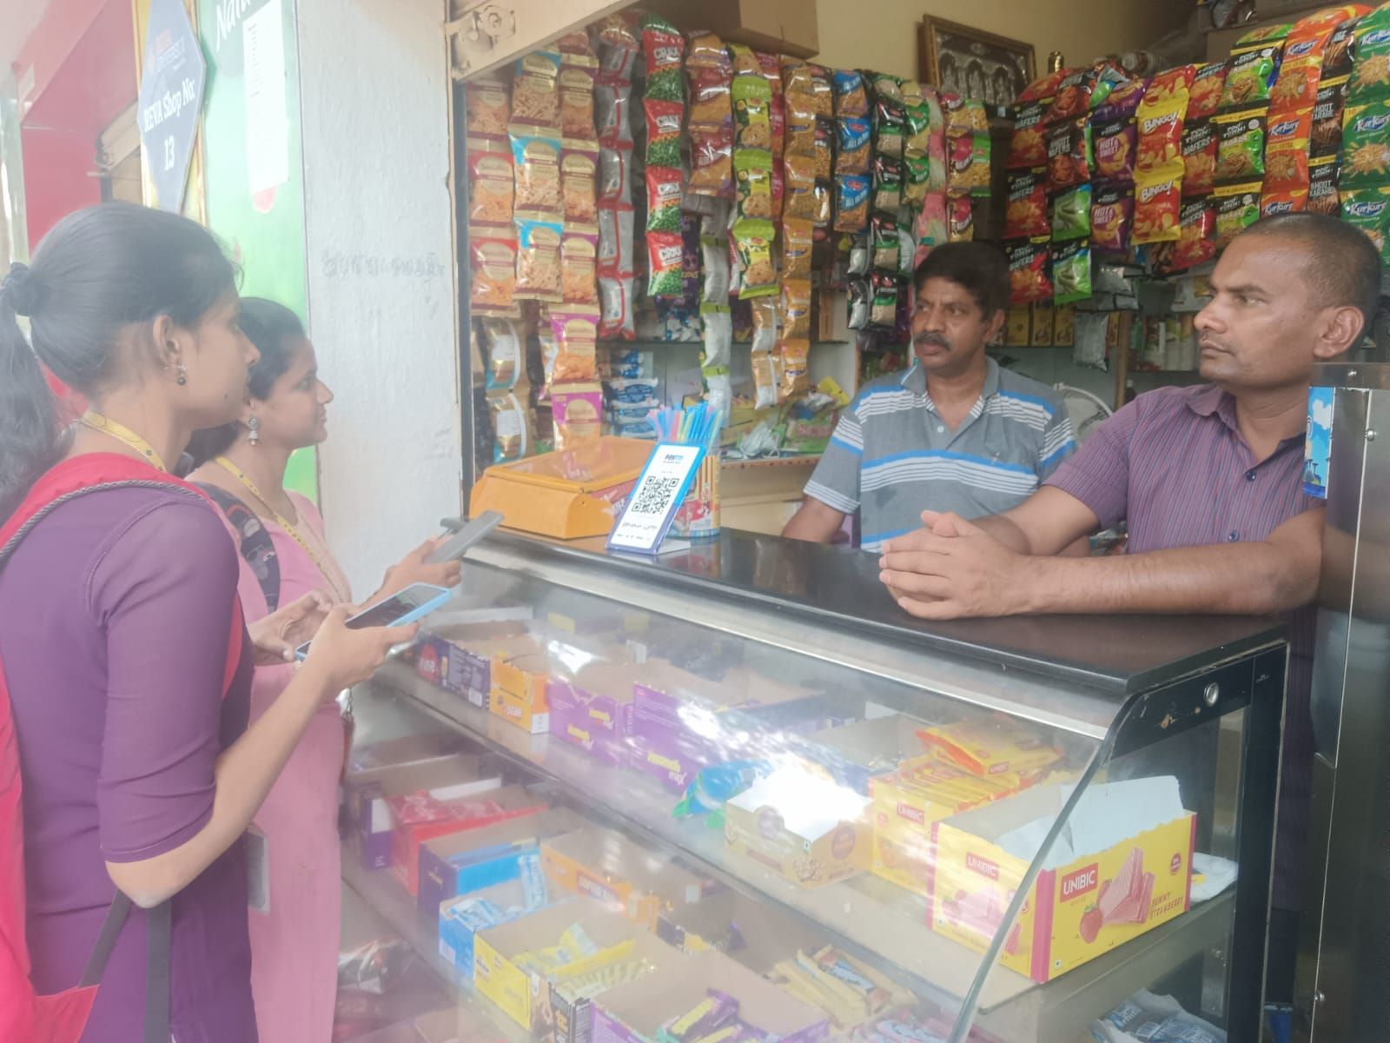

Name:Ganesh
Shop Name:Aditya juice center
Role:Owner
Business Type:Retail
Who handles GST:Accountant
Pain points:
• Shop owner collects many bills but does not check them properly
• Bills are given to accountant without organizing, causing confusion
• Difficult to know if any bill is missing before giving to accountant
• Owner cannot easily understand GST details in the bills
• No way to track daily expenses and purchases clearly
• Sometimes wrong or incomplete bills are submitted unknowingly

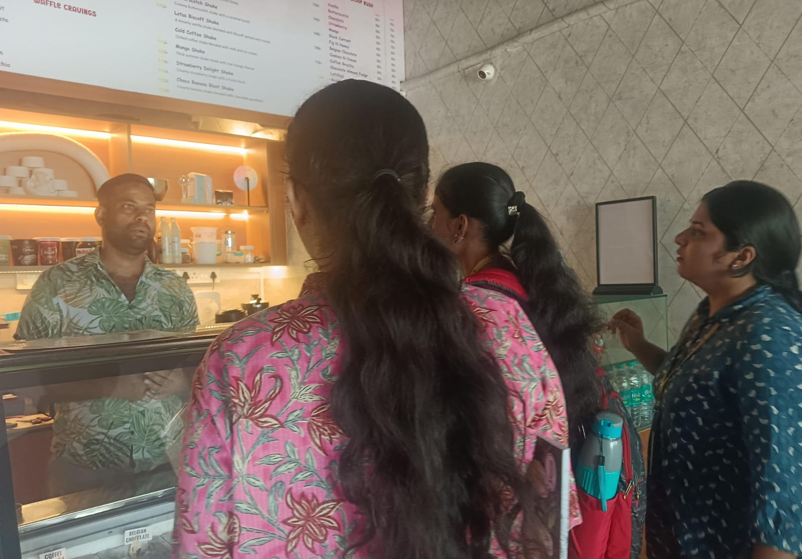

Name:Rizwan
Shop Name: Scoops
Role: Owner
Bussiness Type: Dessert shop
Who handles GST: Accountant
Pain points:
- Errors in GST invoice preparation and tax calculation
- Delay in filing GST returns due to complex procedures
- Challenges in maintaining proper GST records and documentation
- Difficulty in reconciling sales data with GST filings
- Risk of penalties due to incorrect or late GST filing
- Limited knowledge of input tax credit (ITC) benefits
- Dependence on external accountant for GST compliance

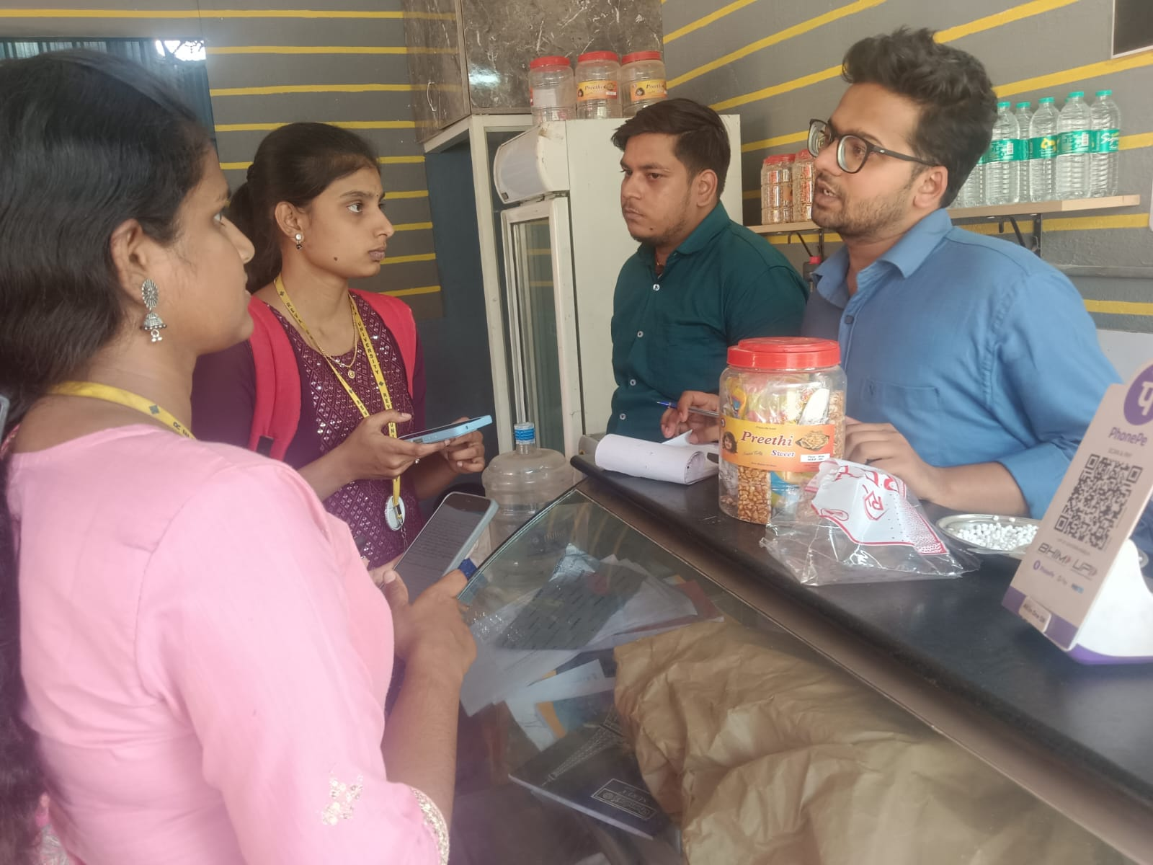

Name: Sayed Ali Khan
Shop Name: Limbu-Chilli Restaurant
Role: Owner
Business Type: Small Restaurant
Who handles GST: Accountant(sometimes owner also involved)
Pain points:
    - Daily transactions are handled by hand (manual entry)
    - Lack of proper digital system for accounting
    - Dependence on accountant for GST-related work
    - Confusion or inconsistency in GST handling
    - Time-consuming bookkeeping process
    - Possible errors due to manual work

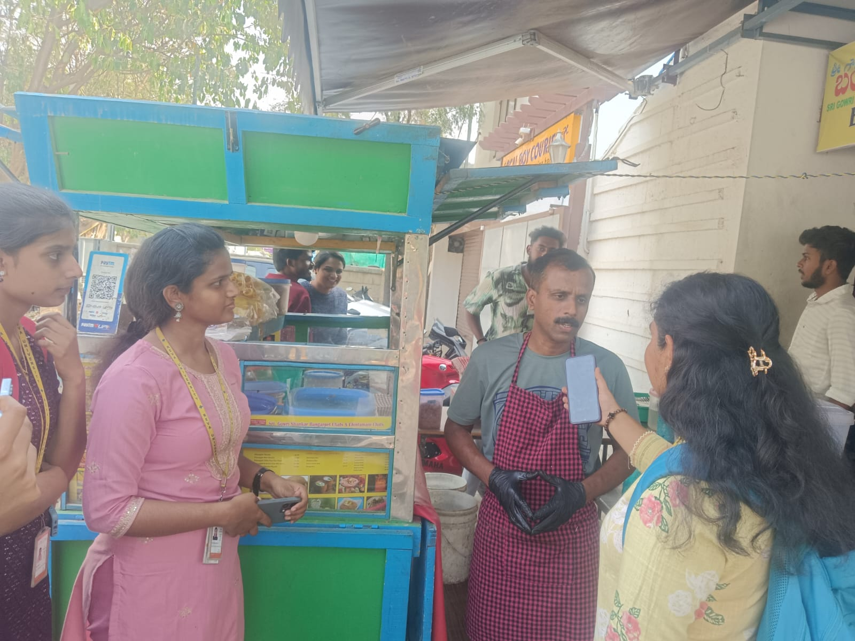

Name:Harish
Shop Name:Bangarpet chats
Role:Owner
Business Type:Chats shop
GST:not applicable(IT filling is done)
Pain points:
• Owner finds it difficult to understand tax rules
• Not sure how to calculate total income correctly
• Difficulty in maintaining proper records of income and expenses
• Fear of making mistakes while filing
• Time-consuming to organize data for filing

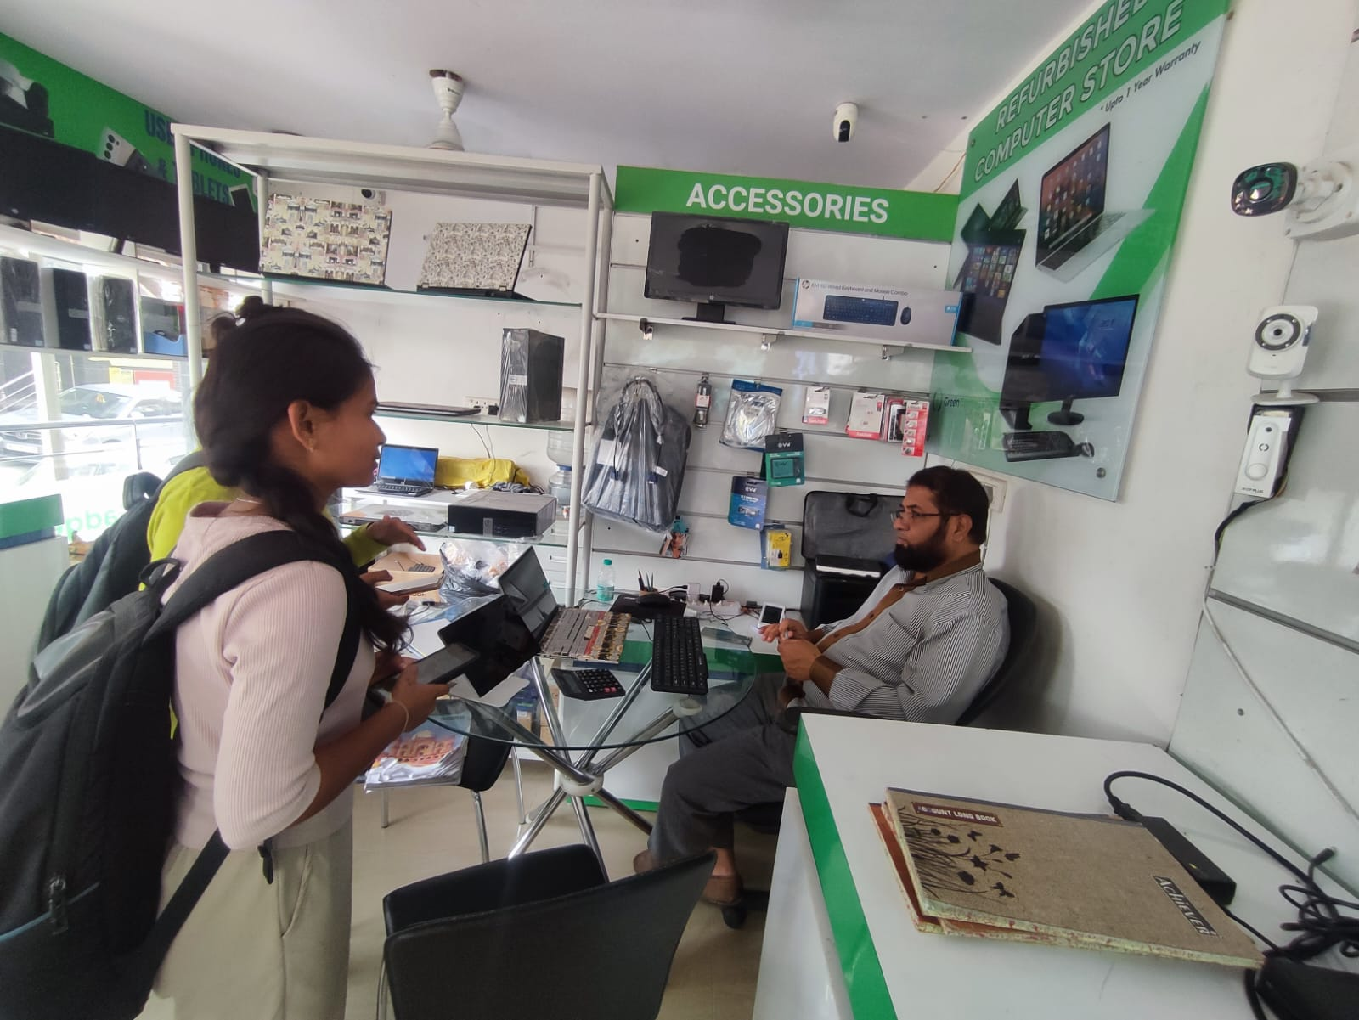

Name: Mohammed Rafi Sheikh
Shop Name: GreenGadgets Computer Store
Role: Shop Owner
Business Type: Refurbished Computer & Accessories Store
Who handles GST: Owner handles a little with the help of external CA support
Pain points:
- Multiple product categories with different GST rates and no unified billing system
- Refurbished and new accessories attract different GST rates, creating billing complexity
- Fully dependent on CA for GST filing with no real-time visibility into tax liability
- No integrated invoicing system, leading to errors and delays in monthly GST returns

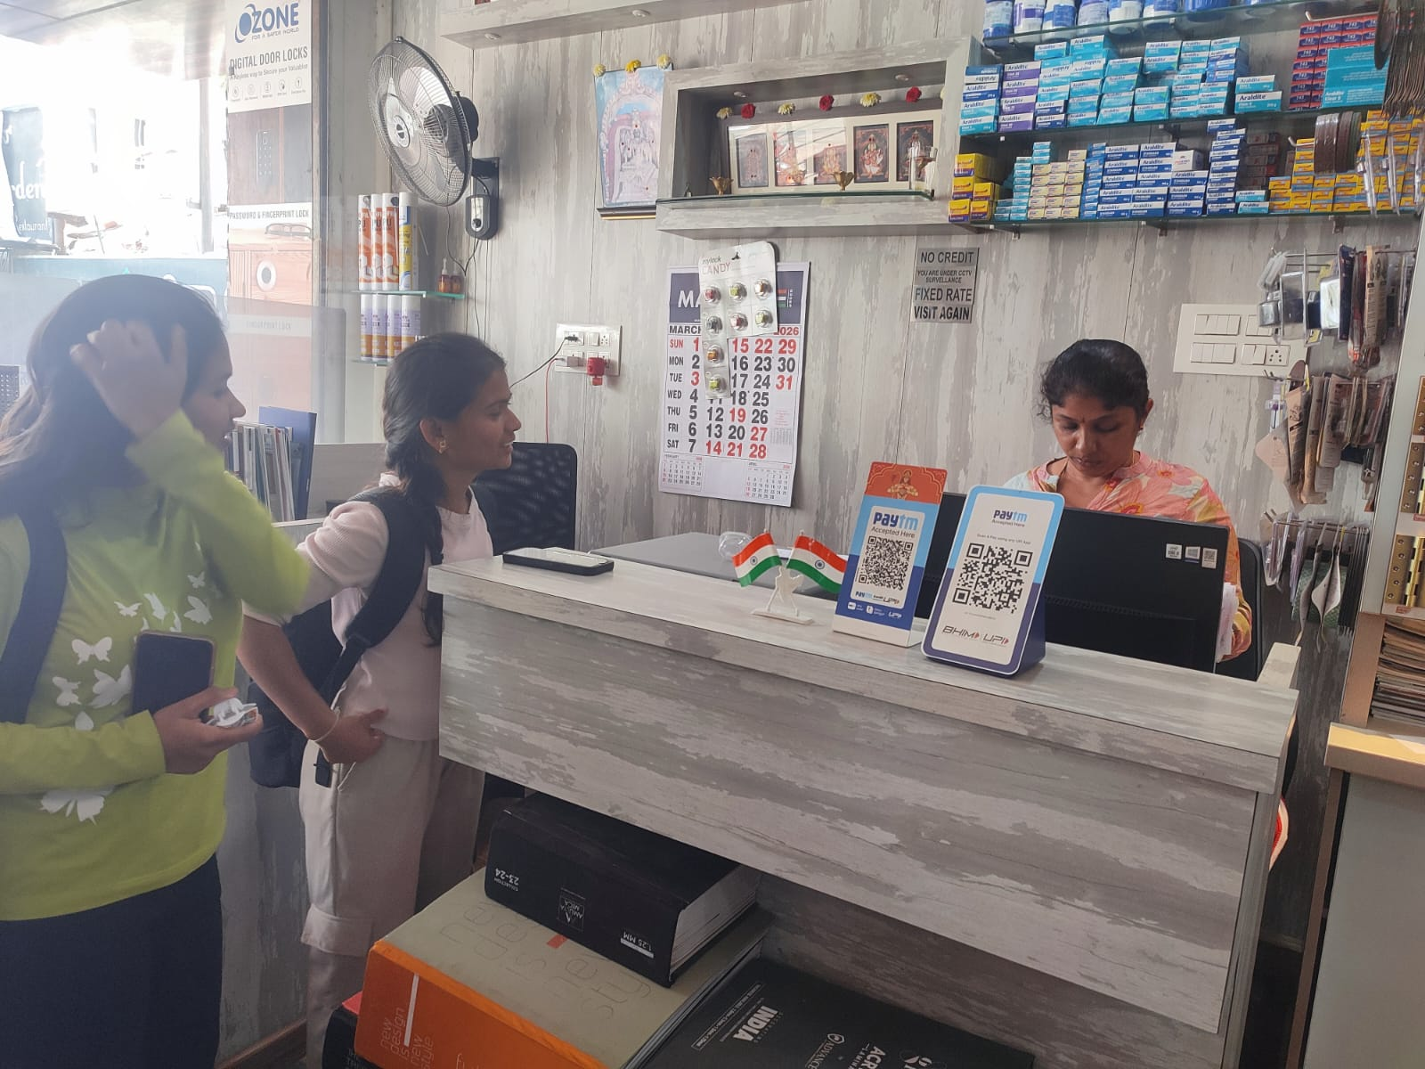

Name: Deepa Nair
Shope Name: Sagar Trading Company ( Door Locks & Hardware Store)
Role: Shop Owner
Business Type: Digital Door Locks & Hardware Store
Who handles GST: Owner herself handles the GST filling does around 10 filling a day depending on the number of invoices they get
Pain points:
- Managing GST across diverse hardware product categories (locks, electricals, accessories) with different tax slabs
- No dedicated accounting software; relies on manual billing and Paytm/BHIM UPI for payments
- Fixed-rate, no-credit policy makes it harder to issue proper GST invoices for every transaction



Name: Kiran Mehta
Shop Name:Aditya Pharmacy
Role: Pharmacist / Shop Owner
Business Type: Medical & Pharmacy Store
Who handles GST: External CA handles all GST filing and compliance
Pain points:
- Hundreds of medicine SKUs with varying GST rates (0%, 5%, 12%) making classification difficult
- Manual reconciliation of purchase invoices from multiple pharma distributors every month
- No automated billing system to track GST liability and ITC simultaneously

Google form survey
survey form link
survey response link

